# DC Motor position control

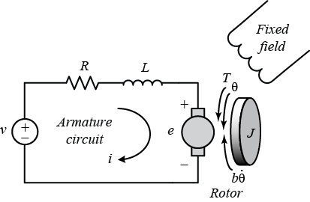

The DC motor is a typical actuator in control systems. When combined with wheels, drums, and cables, it can also produce translational motion in addition to rotary motion. The figure displays the rotor's free-body diagram as well as the armature's electric equivalent circuit.

**Project**

1. System Modeling:
   * Develop a mathematical model of the system using first principles.
2. Controller Design:
   * Choose a control strategy.
   * Design the controller gains based on the system model and desired performance criteria, such as stability and response time.
3. Software implementation:
   * Use MATLAB to simulate the system and to implement the control algorithm in simulation.
4. Documentation and Presentation:
   * Document your work in a report summarizing the project, including the system modelling, controller design, and results analysis.
   * Make a presentation to discuss the project and present the results to the class